CORRELATION / REGREESION ANALYSIS

DATE: 8.01.2020

REG NO: 19BCS0012

NAME : NITHISH.G

QUESTION;

1. FIND THE CORRELATION COEFFIENT FOR THE FOLLOWING DATA.

|  |  |
| --- | --- |
| X | Y |
| 1 | 650 |
| 2 | 550 |
| 4 | 450 |
| 1 | 500 |
| 3 | 475 |
| 4 | 425 |
| 2 | 565 |
| 2 | 525 |
| 6 | 400 |
| 3 | 480 |

PROCEDURE:

1. DECLARE THE VARIABLES ‘X’ AND ‘Y’ IN VARIABLE VIEW,
2. FEED THE VALUES FOR X AND Y IN VARIABLE VIEW,
3. THEN CLICK GRAPHS

LAGACY DIALOGS

SCATTER/DOT

SMIPLE SCATTER

DEFINE X AND Y AXIS

RESULT

OUT PUT;

VARIABLE VIEW:



DATA VIEW:

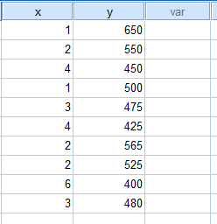

GRAPH ANALYS;

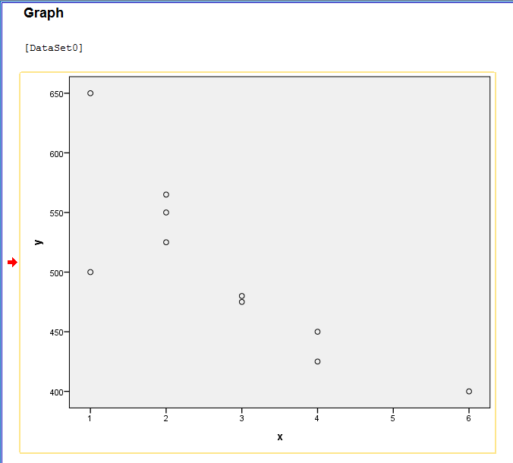

REGRESSION

PROCEDURE:

1. CLICK ANALYSE

REGRESSION

LINEAR REGRESSTION

X DEPENDENT

Y INDEPENDENT

APPLY VALUES IN THE EQUATION

X=MY+C;

RESULT

**Regression**

|  |  |  |  |
| --- | --- | --- | --- |
| **Variables Entered/Removeda** | | | |
| Model | Variables Entered | Variables Removed | Method |
| 1 | yb | . | Enter |
| a. Dependent Variable: x | | | |
| b. All requested variables entered. | | | |

|  |  |  |  |  |
| --- | --- | --- | --- | --- |
| **Model Summary** | | | | |
| Model | R | R Square | Adjusted R Square | Std. Error of the Estimate |
| 1 | .837a | .701 | .664 | .899 |
| a. Predictors: (Constant), y | | | | |

|  |  |  |  |  |  |  |
| --- | --- | --- | --- | --- | --- | --- |
| **ANOVAa** | | | | | | |
| Model | | Sum of Squares | df | Mean Square | F | Sig. |
| 1 | Regression | 15.141 | 1 | 15.141 | 18.755 | .003b |
| Residual | 6.459 | 8 | .807 |  |  |
| Total | 21.600 | 9 |  |  |  |
| a. Dependent Variable: x | | | | | | |
| b. Predictors: (Constant), y | | | | | | |

|  |  |  |  |  |  |  |
| --- | --- | --- | --- | --- | --- | --- |
| **Coefficientsa** | | | | | | |
| Model | | Unstandardized Coefficients | | Standardized Coefficients | t | Sig. |
| B | Std. Error | Beta |
| 1 | (Constant) | 11.628 | 2.058 |  | 5.650 | .000 |
| y | -.018 | .004 | -.837 | -4.331 | .003 |
| a. Dependent Variable: x | | | | | | |

**X=-0.018+11.628**

**THE VALUE OF X=11.610**

**LET KEEP X HAS INDEPENDENT AND Y HAS DEPENDENT**

|  |  |  |  |
| --- | --- | --- | --- |
| **Variables Entered/Removeda** | | | |
| Model | Variables Entered | Variables Removed | Method |
| 1 | xb | . | Enter |
| a. Dependent Variable: y | | | |
| b. All requested variables entered. | | | |

|  |  |  |  |  |
| --- | --- | --- | --- | --- |
| **Model Summary** | | | | |
| Model | R | R Square | Adjusted R Square | Std. Error of the Estimate |
| 1 | .837a | .701 | .664 | 42.778 |
| a. Predictors: (Constant), x | | | | |

|  |  |  |  |  |  |  |
| --- | --- | --- | --- | --- | --- | --- |
| **ANOVAa** | | | | | | |
| Model | | Sum of Squares | df | Mean Square | F | Sig. |
| 1 | Regression | 34320.417 | 1 | 34320.417 | 18.755 | .003b |
| Residual | 14639.583 | 8 | 1829.948 |  |  |
| Total | 48960.000 | 9 |  |  |  |
| a. Dependent Variable: y | | | | | | |
| b. Predictors: (Constant), x | | | | | | |

|  |  |  |  |  |  |  |
| --- | --- | --- | --- | --- | --- | --- |
| **Coefficientsa** | | | | | | |
| Model | | Unstandardized Coefficients | | Standardized Coefficients | t | Sig. |
| B | Std. Error | Beta |
| 1 | (Constant) | 613.611 | 29.107 |  | 21.081 | .000 |
| x | -39.861 | 9.204 | -.837 | -4.331 | .003 |
| a. Dependent Variable: y | | | | | | |

THE VALUE OF Y=MX+C;

Y=-39.861+613.611

Y=573.75